API for InfiniteChat support

Context
In Supporting Infinite Chat.docx, we discussed the authentication mechanism for supporting Infinite Chat.
In this document, we discuss the websocket connection and the Message that will transition over the network.

API: GetChats
We went through the first activation of this sequence diagram (green bar), which happens on the client side. Now that we have an authenticated connection established with backend, let’s delve into what is happening next on the server-side activation (orange bar).
As hinted in the Authentication document, the first step after acquiring authentication token will be to GetOrCreate the user’s main conversationId, based on the userId. For anonymous users, it implies that clearing auth cookies, will reset the conversation.
To complete this operation, we suggest using the existing `/GetChats` endpoint.
The purpose of `GetChats` is to list all the active “chats” or “threads” that a user have. Leveraging this endpoint for this scenario will make sure that we can seamlessly support threads on the mobile app (not only a single main thread).
The following flow diagram shows the current functioning of `GetChats`, in blue, with the suggested addition.
- Extract UserId from user_token.
  - As of today, we use a proxy on userId (participantId) but request validation also enforce that the same userId is used in request and token.
- Get Chats (aka threads) metadata from ObjectStore for the given userId.
  - This is the core business logic (or api implementation) for /GetChats.
- Create or assign main chat for the current user
  - This is the new piece of logic for `GetChats`
  - Open questions:
    - Do we always run the “main chat” block or bind the feature to the new AppId?
    - When the chats list is not empty, do we still create a new chat or pick one in the list and mark it as “main”?
    - Do we need an additional feature to only load the main chat metadata and ignore other threads for now?
      - It doesn’t seem necessary because all users will have only one chat to start with anyway.
GetChats contract is documented here: https://dev.azure.com/msasg/WIT%20Engineering/_git/TuringAtWork?path=/sydney&anchor=%60/getchats%60
Example - GET
> https://services.bingapis.com/sydney/GetChats?request={"participant":{"id":"user-id"},"source":"your-project-name","traceId":"random-guid"}
Example response body:
{
"chats": [
{
“chatType”: “Main”,
"conversationId": "<conversation-id>",
"chatName": "…",
"createTimeUtc": 1683324218827,
"updateTimeUtc": 1683324246381
}
],
"result": {
"value": "Success",
"message": "GetChats: get chats successfully.",
"serviceVersion": "<current-service-version>"
}
}

From here, the client has everything it needs to start loading the main chat content, through `/GetConversation` API and interact with the Chat, potentially in parallel.

API: GetConversation
Existing API. No change required. Documented here: https://dev.azure.com/msasg/WIT%20Engineering/_git/TuringAtWork?path=/sydney&anchor=%60/getconversation%60
Example – GET:
https://sydney.bing.com/sydney/GetConversation?conversationId=d37dc49b-0ba6-42d9-8c39-dea26b6e7a45&participantId=<user ID>&source=<your project name>&traceId=<ID to track the session across services>
{
"messages": [
{
"text": "Hi! How are you?",
"author": "user",
"locale": "en-us",
"market": "en-us",
"messageId": "46c363ea-3479-4032-8023-02f41d4451b4",
"requestId": "46c363ea-3479-4032-8023-02f41d4451b4",
"offense": "None"
},
{
"text": "Good, just enjoying the rain. What about you?",
"author": "bot",
"messageId": "acc50e3a-f0dc-41c1-a57b-4abfbd5cc114",
"requestId": "1281b3f4-7840-4b08-b795-90515f10ea0d",
"offense": "None",
"contentOrigin": "Chitchat"
}
],
"result": {
"value": "Success"
}
}

API: ChatHub
No change needed here. ChatHub can be called with user_token and conversationId acquired during previous steps/APIs calls. Documented here: https://dev.azure.com/msasg/WIT%20Engineering/_git/TuringAtWork?path=/sydney&anchor=%60/chat%60

API: VoiceChatHub(liuzhi)
VoiceChatHub uses a SignalR streaming endpoint to receive voice data and deliver response text along with voice data. Each conversation utilizes individual SignalR connections, utilizing ChatHub for each user's chat request in the conversation.

Architecture
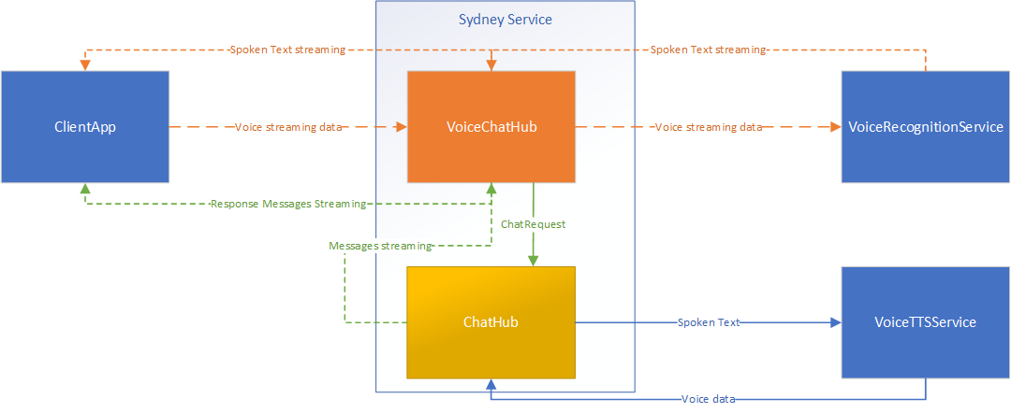

Sequence

API(Draft)
- Input streaming messages:
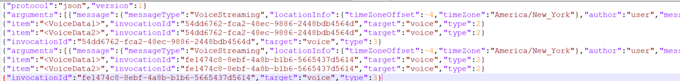

- Output streaming messages(TBD)
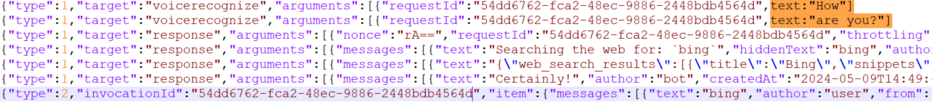
Streaming output from Sydney on websocket works the same for ChatHub and VoiceChatHub.
The only difference is that ChatHub setup streaming channels AND tear them down within Chat method, whereas for VoiceChatHub, we want to allow output stream between multiple Stream "requests" or "methods".

- API definition

